**Experiment No. 3.2**

**Student Name: Rishav Kumar UID: 22MCC20039**

**Branch: MCA - CCD Section/Group: MCD-1/ Grp A**

**Semester: IV Date of Performance: 10th Apr 24**

**Subject Name: CI/CD Pipelines Subject Code: 22CAP-781**

1. **Aim/Overview of the practical:**

Create a build node and assign maven based job to that build node.

1. **Code for practical:**

* Open Jenkins on localhost.
* Click on Manage Jenkins > Credentials > System > Add
* Create a new Credentials using SSH
* Save ssh path to ~/.ssh/jenkins_agent_key
* Create SSH Key using command

***ssh-keygen -f ~/.ssh/jenkins_agent_key***

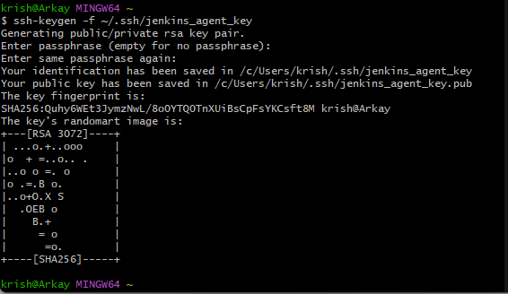

* You can open it using ***nano ~/.ssh/Jenkins_agent_key***
* Copy the certificate ad Go to Manage Jenkins > Credentials > System > Add credentials and paste certificate.

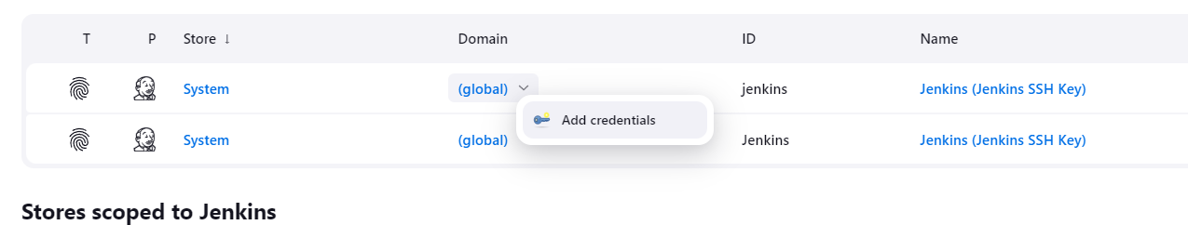

* Run command

***docker run -d --rm --name=agent1 --network jenkins -p 22:22 `***

***>> -e "JENKINS_AGENT_SSH_PUBKEY=[your-public-key]" `***

***>> jenkins/ssh-agent:jdk17***

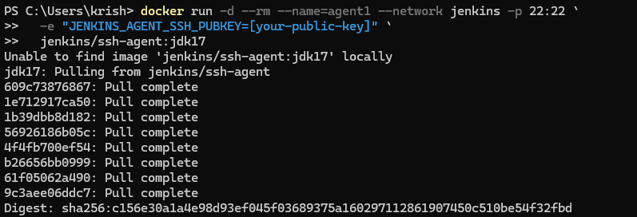

* Click on Manage Jenkins > Nodes.
* Create a node and select Connect with SSH and select Jenkins SSH.

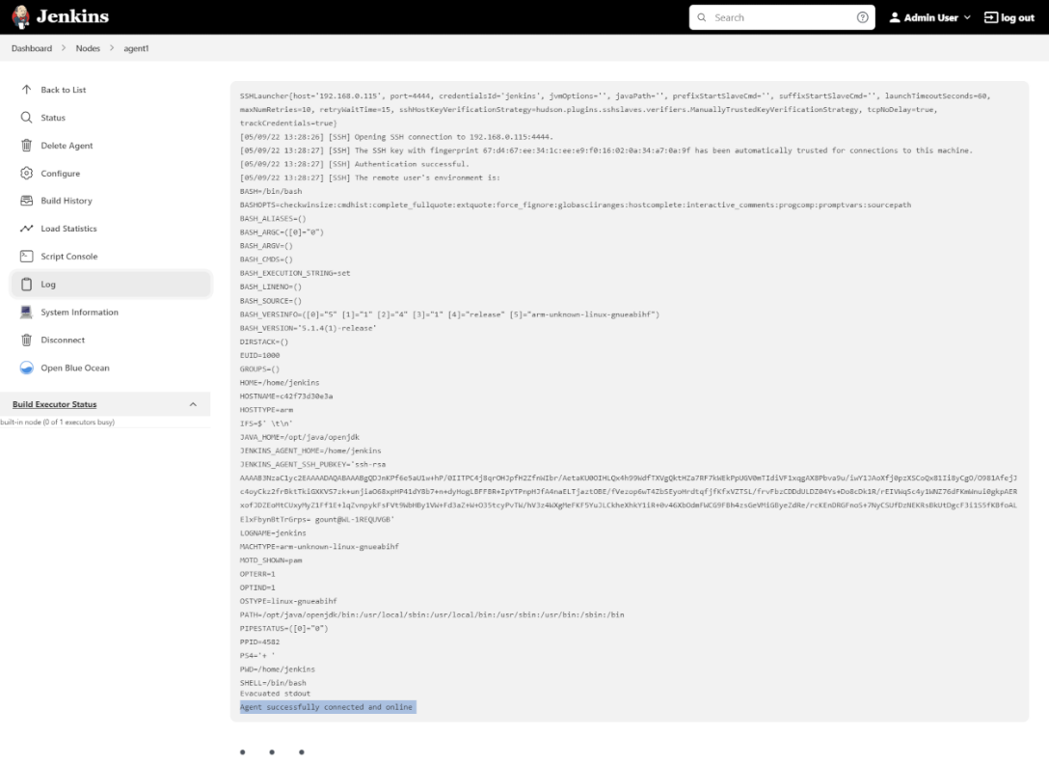

* After creating node, Create a job to node and click on Build.

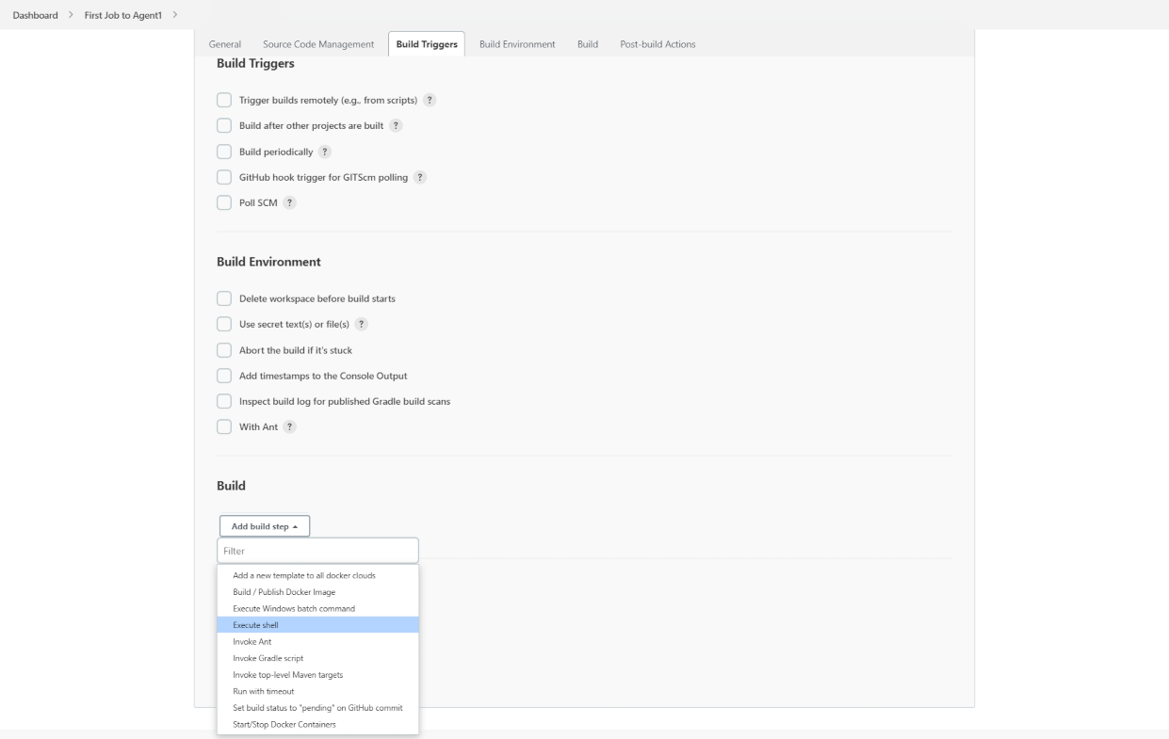

* Build will be completed in few moments.